Reliability and Safety Analysis

Year: 2022 Semester: Spring Team: 08 Project: Gimbal Vehicle

Creation Date: ­4/1/2022 Last Modified: ­4/1/2022

Author: Zeren Li Email: li3103@purdue.edu

Assignment Evaluation:

|  |  |  |  |  |
| --- | --- | --- | --- | --- |
| **Item** | **Score (0-5)** | **Weight** | **Points** | **Notes** |
| **Assignment-Specific Items** | | | | |
| **Reliability Analysis** |  | x2 |  |  |
| **MTTF Tables** |  | x3 |  |  |
| **FMECA Analysis** |  | x2 |  |  |
| **Schematic of Functional Blocks (Appendix A)** |  | x2 |  |  |
| **FMECA Worksheet (Appendix B)** |  | x3 |  |  |
| **Writing-Specific Items** | | | | |
| **Spelling and Grammar** |  | x2 |  |  |
| **Formatting and Citations** |  | x1 |  |  |
| **Figures and Graphs** |  | x2 |  |  |
| **Technical Writing Style** |  | x3 |  |  |
| **Total Score** |  | | |  |

5: Excellent 4: Good 3: Acceptable 2: Poor 1: Very Poor 0: Not attempted

Comments:

*Comments from the grader will be inserted here.*

1. Reliability Analysis

STM32F446 is a microcontroller that controls the movement of the vehicle, moving of the gimbal and provides a platform for the IMU parameter calculations. It has 144 pins so any mishandling of the microcontroller could lead to irreversible damage and thus shutting down the whole vehicle system. The failure per 10^6 hours (𝝀𝑷) is calculated based on the formulas 𝝀𝑷 = (C1 · πt + C2· πe) ·πlπq outlined in MIL-HDBK-217F. Mean time to failure (MTTF) was calculated by MTTF = 1 / 𝝀𝑷. A failure of STM32F446 will generate heat and shut down the vehicle system but not cause any direct damage to the user.

Table 1. STM32F446 analysis

|  |  |  |  |
| --- | --- | --- | --- |
| **Parameter name** | **Description** | **Value** | **Comments** |
| C1 | Die complexity | 0.56 | 32bit MCU |
| πt | Temperature coefficient. | 0.98 | Worst case operating temperature at 85°C |
| C2 | Pin/Package Constant | 0.063 | 144pins |
| πe | Environmental Constant | 0.5 | 𝑮𝑩 |
| πl | Learning Factor | 1 | Produced over 2 years |
| πq | Quality Factor | 10 | Commercial components |
| Entire design: |  |  |  |
| 𝝀𝑷 |  | 8.715 |  |
| MTTF |  | 0.1147 |  |

STM32F091 is a microcontroller that inputs and processes the joysticks data and communicate them with the wireless transmitter module. it is chosen for reliability analysis because it has 64 pins and mishandling will completely damage the microcontroller. The failure per 10^6 hours (𝝀𝑷) is calculated based on the formulas 𝝀𝑷 = (C1 · πt + C2· πe) ·πlπq outlined in MIL-HDBK-217F. Mean time to failure (MTTF) was calculated by MTTF = 1 / 𝝀𝑷. A failure of STM32F091 will generate heat and shut down the controller system but not cause any direct damage to the user.

Table 2. STM32F091 analysis

|  |  |  |  |
| --- | --- | --- | --- |
| **Parameter name** | **Description** | **Value** | **Comments** |
| C1 | Die complexity | 0.56 | 32bit MCU |
| πt | Temperature coefficient. | 0.98 | Worst case operating temperature at 85°C |
| C2 | Pin/Package Constant | 0.025 | 64pins |
| πe | Environmental Constant | 0.5 | 𝑮𝑩 |
| πl | Learning Factor | 1 | Produced over 2 years |
| πq | Quality Factor | 10 | Commercial components |
| Entire design: |  |  |  |
| 𝝀𝑷 |  | 8.25 |  |
| MTTF |  | 0.12 |  |

The I50115 is a voltage regulator that is used in the digital circuits to change the input voltage to a desired voltage. Its reliability is concerned because the failure of this voltage regulator will provide insufficient or excessive amount of power to the microcontroller, in which case the MCU will shut down. To calculate the failure per 10^6 hours, the model of microcircuit section from MIL-HDBK-217F is used. The formula is 𝜆𝑃 = (C1 · πt + C2· πe) · πl · πq. The MTTF was calculated by MTTF = 1 / 𝝀𝑷. Any failure of I50115 will not cause any direct damage to the user.

Table 3. I50115 analysis

|  |  |  |  |
| --- | --- | --- | --- |
| **Parameter name** | **Description** | **Value** | **Comments** |
| C1 | Die complexity | 0.01 | 1 to 100 bipolar transistors |
| πt | Temperature coefficient. | 0.98 | Worst case operating temperature at 85°C based on the overall system temperature |
| C2 | Pin/Package Constant | 0.00092 | 3-pins |
| πe | Environmental Constant | 0.5 | 𝑮𝑩 |
| πl | Learning Factor | 1 | Produced over 2 years |
| πq | Quality Factor | 10 | Commercial components |
| Entire design: |  |  |  |
| 𝝀𝑷 |  | 0.1026 |  |
| MTTF |  | 9.7465 |  |

Summary

The overall system of this project is reliable. The MTTF for each component is long enough for the vehicle and controller to work properly. To improve the reliability for the system, one method is to change the buck convert I50115 to a converter that outputs 3A current. A larger current can improve the reliability of the gimbal servo on the vehicle.

1. Failure Mode, Effects, and Criticality Analysis (FMECA)

There are two major parts for our project: Controller and Vehicle. There are 6 subparts for the Controller: Power Supply, Mode Selection, Radio Module, Program port, ADC reference Voltage, Transmission success indicator and the microcontroller. The schematic is listed in Appendix A figure 1. The power supply of the controller is provided by a 5V battery. A failure of the voltage regulator at the power supply will just shut down the whole controller system and the rest of the functional blocks will not be able to work. The failure of the ADC Reference Voltage and Transmission success indication will not influence the system since their jobs are to enhance the reading of the joystick value and work as an indicator. The Radio module theoretically should not fail. But in practice, there was a time that the radio transmitter broke itself. The controller was not able to send data to the vehicle end. When we replaced a new transmitter, the system was able to come back to work properly. At the failure of the microcontroller, the controller will not work.

The vehicle has 8 parts: Motor driver, Servo header, Motor header, power supply 3.3v, power supply 5v, MPU6050, OLED, and the microcontroller block. The schematic is listed in Appendix A figure 5. The Servo header, Motor header, OLED, MPU6050 and Motor driver have good reliability. Any failure of one of these components will not affect other components. At the failure of the radio module, the microcontroller will not be able to receive joystick data from the controller end. One possible failure for MPU6050 is the failure of reading yaw, pitch and row data. This failure can be solved by pressing the reset button on the microcontroller to reinitialize the MPU6050. The Microcontroller STM32F446 has a possible failure when the buck converter is not able to provide enough current to the MCU if the user operates the joystick too fast. Upon this failure, the MCU will stop responding. Pressing reset button on the MCU can solve the failure.

There are three criticality levels for the project. High criticality will result burning the MCU and Motor driver, which will lead to fire and release toxic gas. The acceptable failure rate for this level is 10^-10. Medium critically will result permanent damage to the major components of the system. The system will be able to work if the user replaces the damage component. The acceptable failure rate for this level is 10^-7. Low criticality is defined as a failure that can shut down the system while not permanently damage any component of the system. The acceptable failure rate for this level is 10^-6.

3.0 Sources Cited:

[1] “Military Handbook,”1 1990. [Online]. Available: http://snebulos.mit.edu/projects/reference/MIL-STD/MIL-HDBK-217F-Notice2.pdf [Accessed 1 4 2022].

[2] “I50115 Datasheet (PDF) - Murata Power Solutions Inc” [Online]. Available: https://pdf1.alldatasheet.com/datasheet-pdf/view/1242565/MURATA-PS/I50115.html [Accessed 1 4 2020].

[3] “Datasheet – STM32F446xC/E [Online]. Available: https://www.st.com/resource/en/datasheet/stm32f446re.pdf [Accessed 30 May 2022].

[4] “STM32F091RC [Online]. Available: https://www.st.com/en/microcontrollers-microprocessors/stm32f091rc.html [Accessed 30 May 2022].

Appendix A: Schematic Functional Blocks

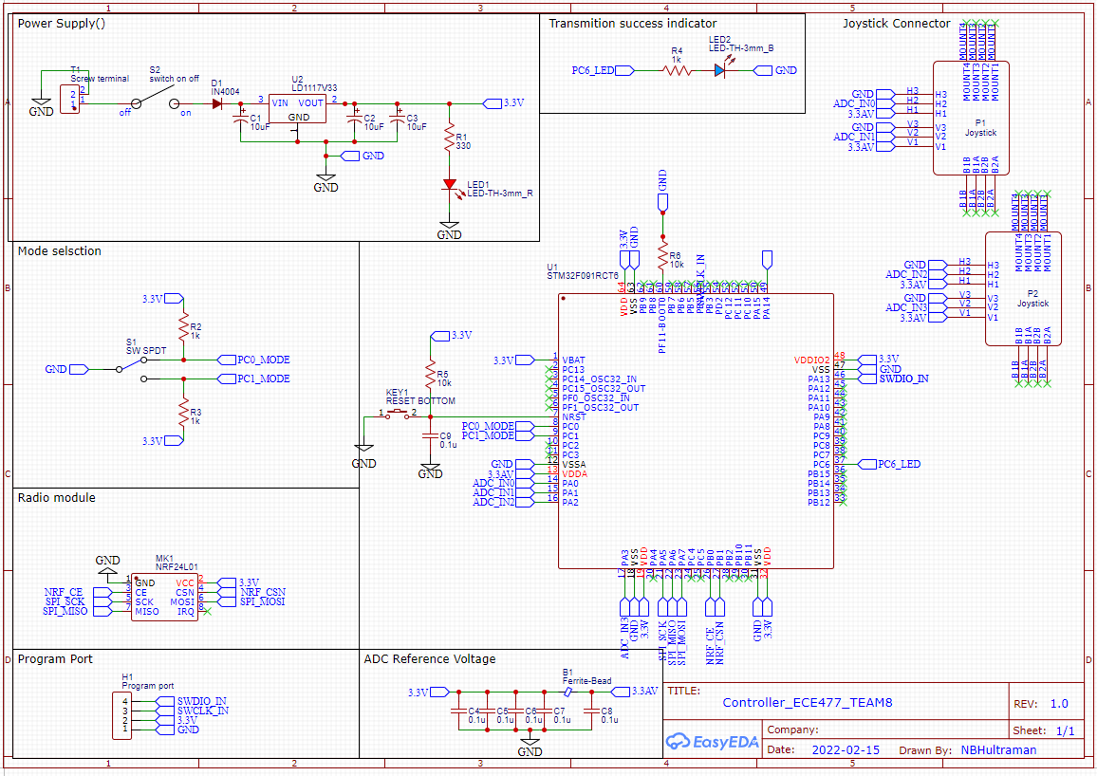

Figure 1 Controller Overview

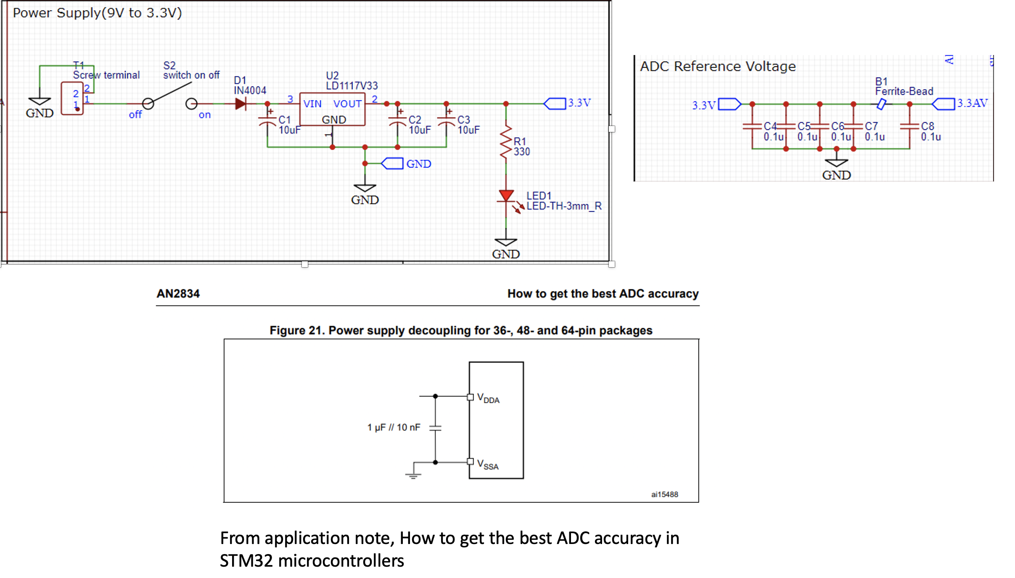

Figure 2

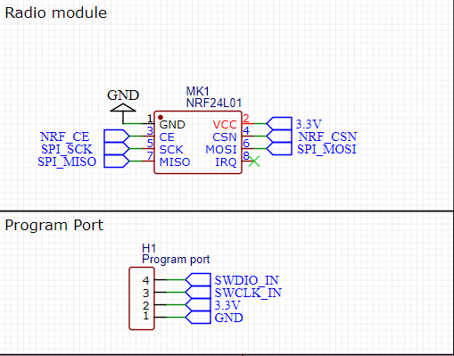

Figure 3

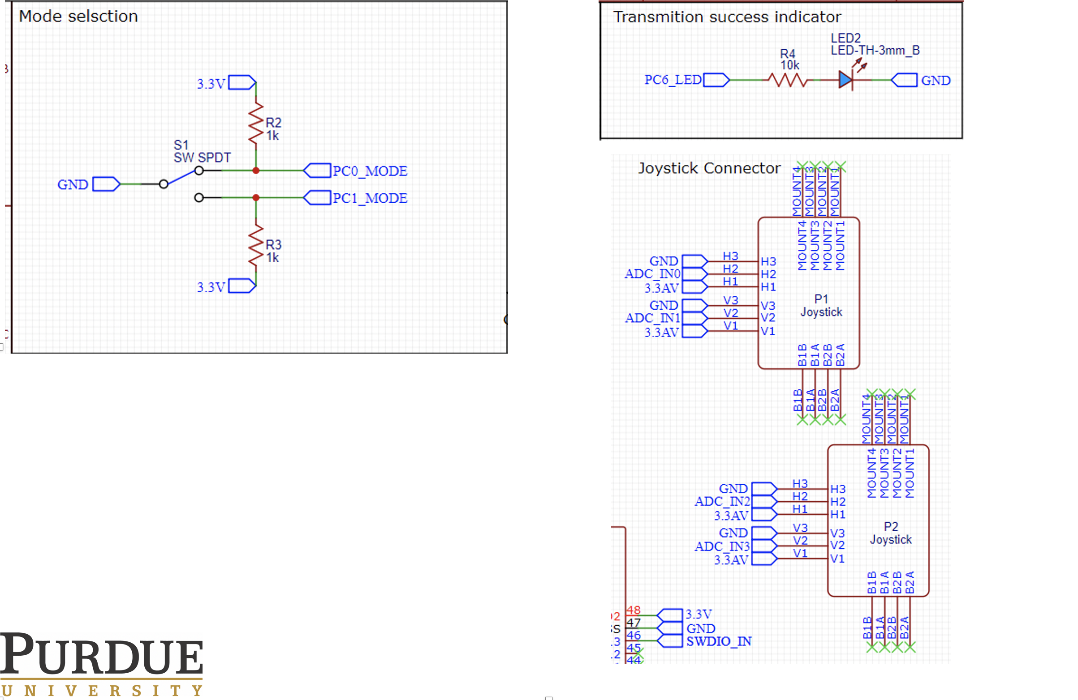

Figure 4

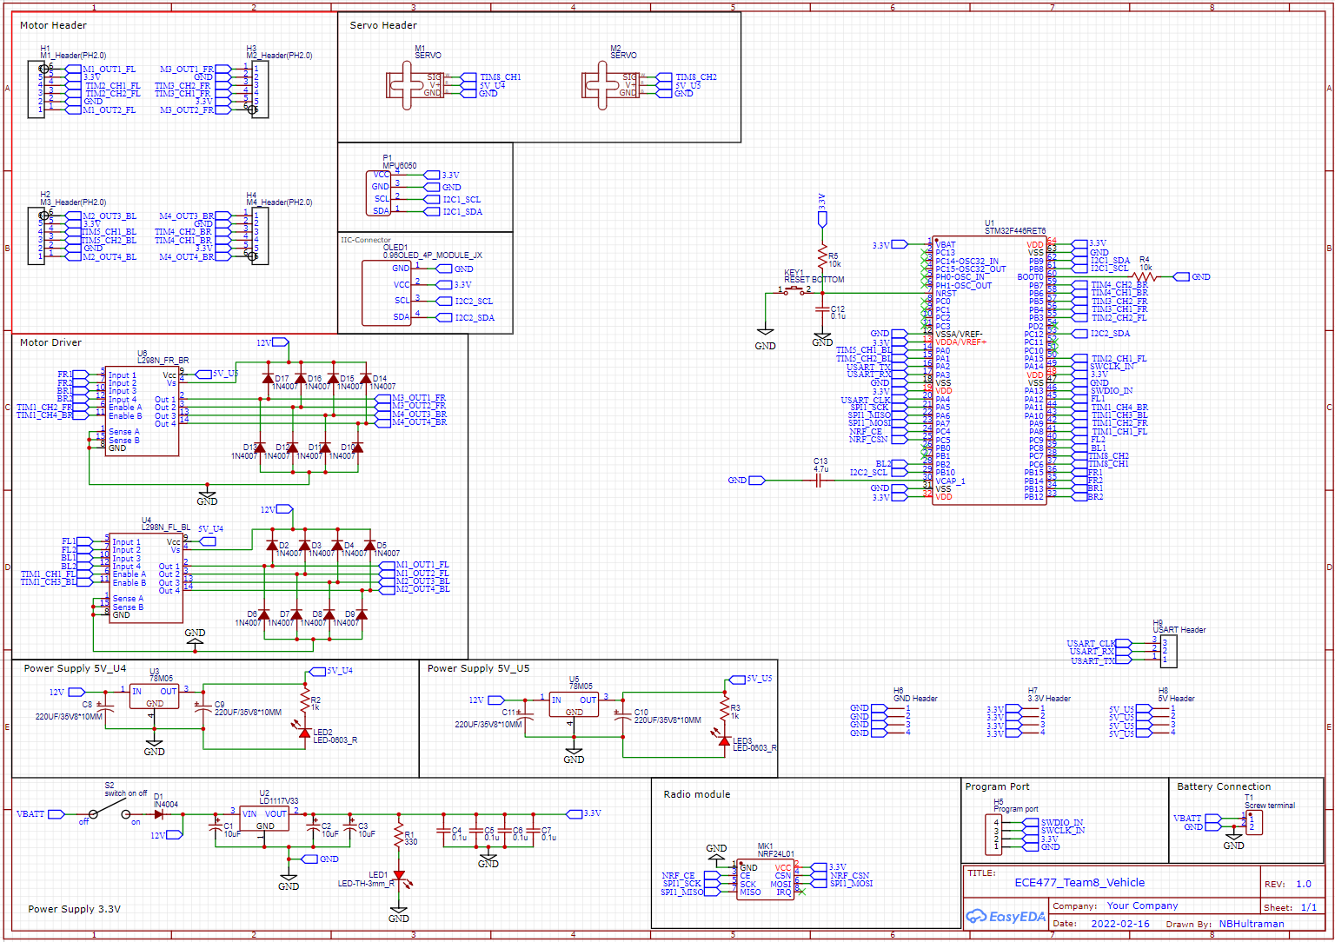

Figure 5 Vehicle Overview

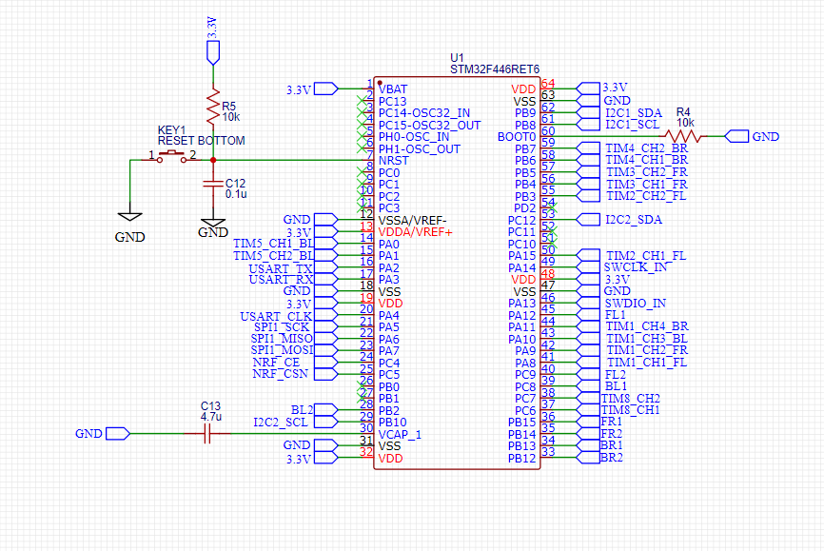

Figure 6

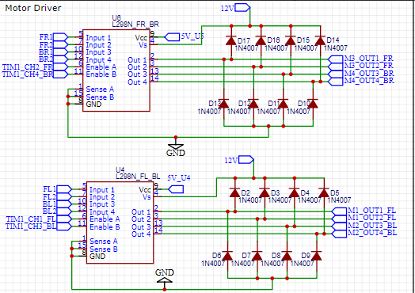

Figure 7

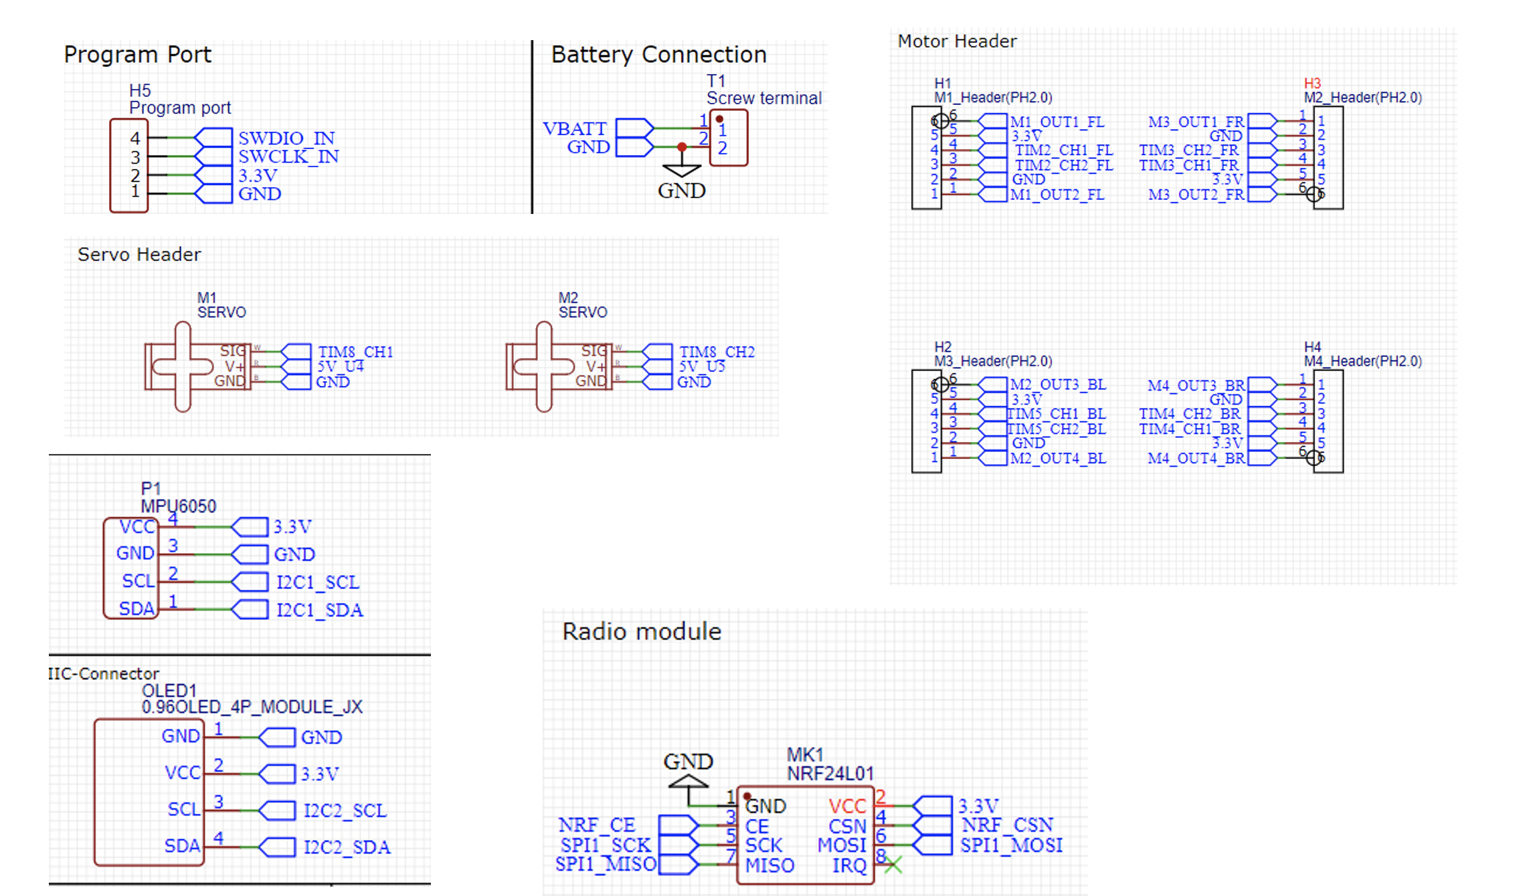

Figure 8

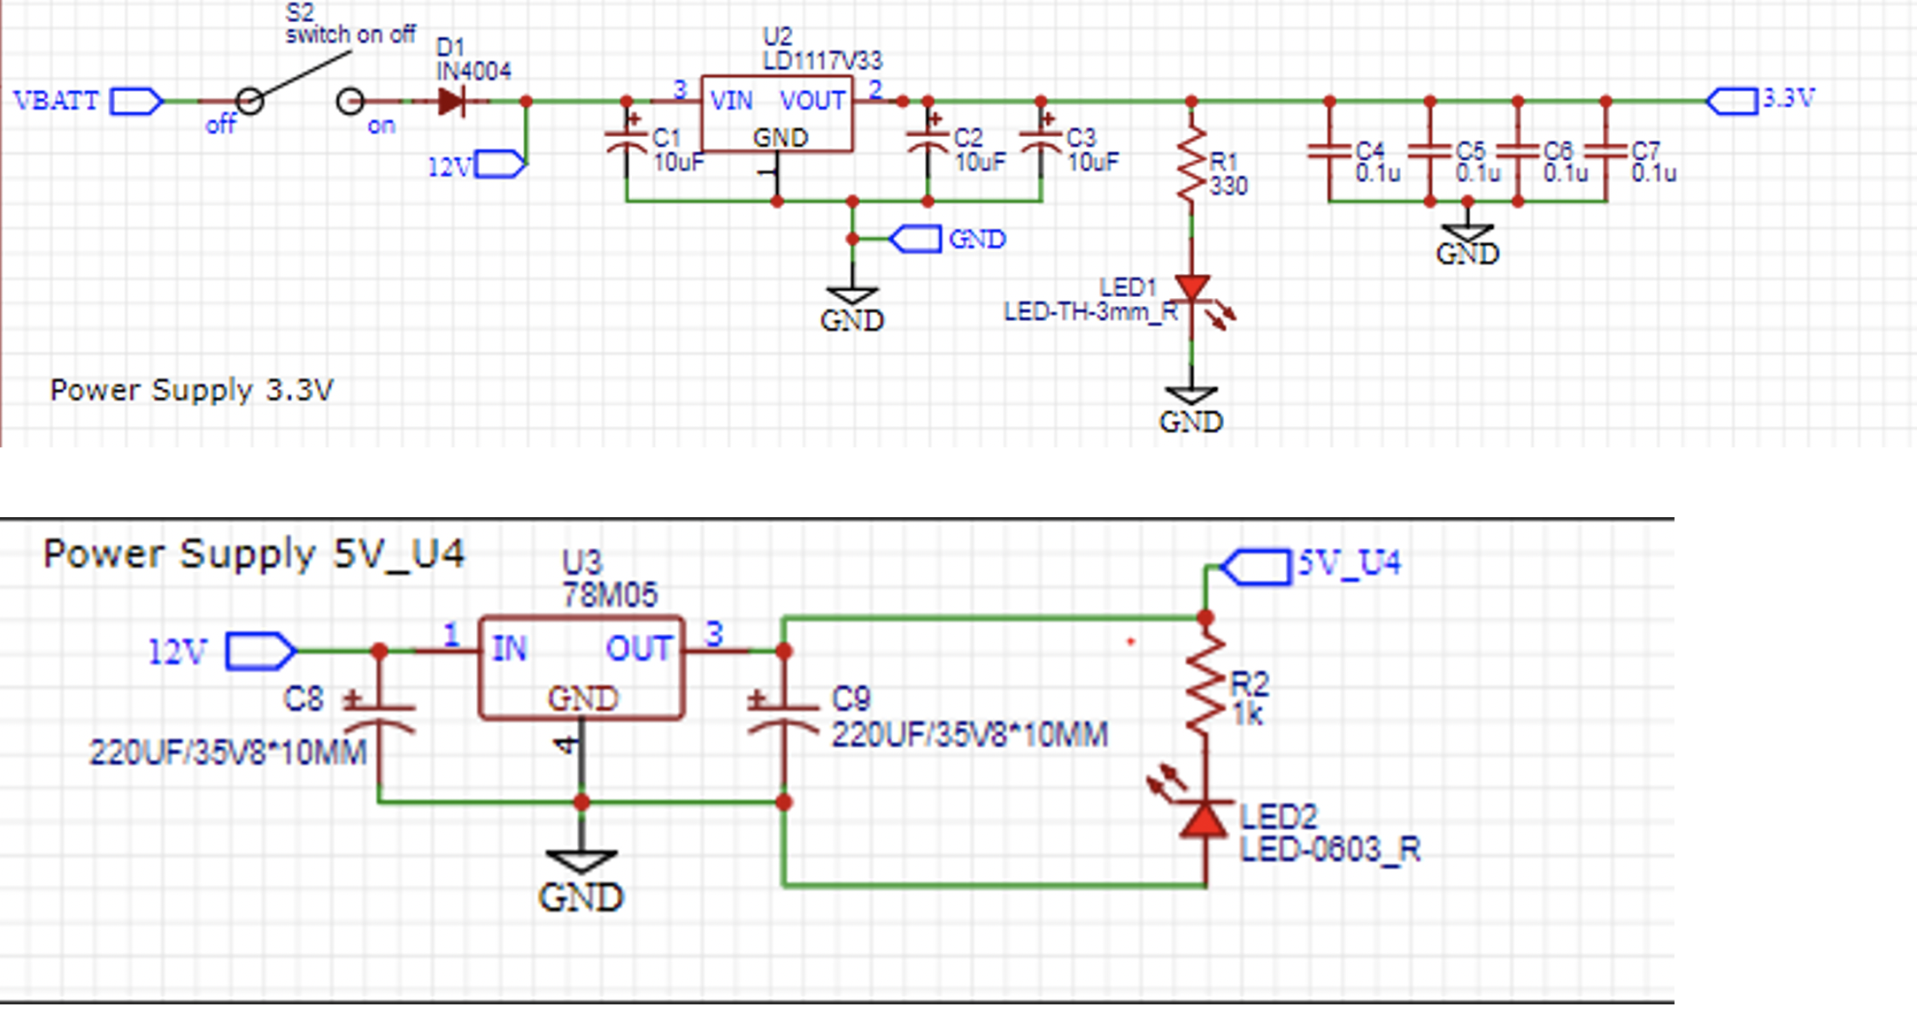

Figure 9

Appendix B: FMECA Worksheet

Table 4. Voltage regulator FEMCA

|  |  |  |  |  |  |  |
| --- | --- | --- | --- | --- | --- | --- |
| Failure No. | **Failure Mode** | **Possible Causes** | **Failure Effects** | **Method of Detection** | **Criticality** | **Remarks** |
| 1 | Not enough current being output | Joystick operating too fast | System shut down. Vehicle will keep moving. | The Vehicle will not be responding to any command | High | The buck converter is not able to respond a very quick change to the input voltage. |
| 2 | Voltage regulator fails shot | Voltage regulator that converts 12v to 5 v | All the ICs and motor drivers will be burned | Smoke/Heating | Medium | All the damaged components need to be replaced in order for the system to work |

Table 5. Power Supply at Vehicle FEMCA

|  |  |  |  |  |  |  |
| --- | --- | --- | --- | --- | --- | --- |
| Failure No. | **Failure Mode** | **Possible Causes** | **Failure Effects** | **Method of Detection** | **Criticality** | **Remarks** |
| 3 | Voltage Drop to low 3.3V | The battery is running out of power | Vehicle System shut down. The MCU cannot be power up and the Vehicle will not be responding to any command | Observation. The Vehicle will not be responding to any command | Low |  |
| 4 | Voltage Drop to low 5.5v | The battery is running out of power | The MCU, OLED and MPU module can power up, but the vehicle does not move | Observation | Low | The motor driver could be damaged |

Table 6. Radio module FEMCA

|  |  |  |  |  |  |  |
| --- | --- | --- | --- | --- | --- | --- |
| Failure No. | **Failure Mode** | **Possible Causes** | **Failure Effects** | **Method of Detection** | **Criticality** | **Remarks** |
| 5 | Transmission/receive module no responding | The chip of the nrf24l01 is damaged | Either the transmitter/receiver end cannot send/receive data | The LED on the controller will no longer lit if the transmitter end is damaged. If the damage is on the receiver end, the vehicle will not respond to any joystick output | Low | Replace a new nrf24l01 module |
| 6 | Transmission/receive module no responding | The distance between two radio modules is out of range | Either the transmitter/receiver end cannot send/receive data | the vehicle will not respond to any joystick output | Low | Attach an antenna to either receiver or transmitter end |

Table 7. MPU6050 FEMCA

|  |  |  |  |  |  |  |
| --- | --- | --- | --- | --- | --- | --- |
| Failure No. | **Failure Mode** | **Possible Causes** | **Failure Effects** | **Method of Detection** | **Criticality** | **Remarks** |
| 7 | Roll data keep increasing | The MPU6050 is not reset properly | Yaw, Pitch and row data can be read. But if the IMU is stable, the value of roll data will keep increasing | Observation of the gimbal or using STM Monitor tool | Low | Press reset button the vehicle to reinitialize MPU6050 |
| 8 | No data reading | The MPU6050 is not reset properly | Yaw, Pitch and row data have no reading. | Observation from STM Monitor Tool. The Gimbal does not move as the vehicle move | Low | Press reset button the vehicle to reinitialize MPU6050 |

Table 8. In-Circuit programmer circuit FEMCA

|  |  |  |  |  |  |  |
| --- | --- | --- | --- | --- | --- | --- |
| Failure No. | **Failure Mode** | **Possible Causes** | **Failure Effects** | **Method of Detection** | **Criticality** | **Remarks** |
| 9 | Not enough voltage supply for the in-circuit programmer | The battery is low | The MCU does not connect to the user’s PC | Error message from the PC | Low |  |